# Implementation Plan

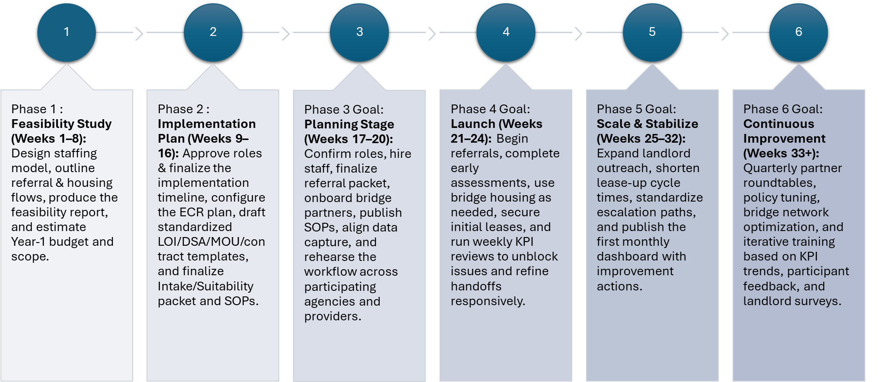

**Phase 1 – Feasibility Study (Weeks 1–8)**

**Goal:** Validate the model and scope.  
**Milestones:** Draft staffing model and salary bands; map referral & housing flows end-to-end; size Year-1 scope (60 participants) and **$3M** budget; confirm pilot counties (Madison, Sangamon, St. Clair); compile feasibility report with risks/assumptions.  
**Outputs:** Steering sign-off on model, flows, budget, and counties; decision to proceed to implementation planning.

**Phase 2 – Implementation Plan (Weeks 9–16)**

**Goal:** Build the foundation to execute.  
**Milestones:** Publish the integrated project timeline; configure **ECR** data plan and core templates (intake, ISP, hotline incident, AP/Invoice); draft standardized **LOI/DSA/MOU/contract** packets; finalize **Intake/Suitability** and **Referral** packets; complete **Payment SOP** (CM sign-off + DocuSign + portal roadmap) and **24/7 Hotline SOP**.  
**Outputs:** Approved SOPs/templates; ECR MVP ready; staff training plan baselined.

**Phase 3 – Planning Stage (Weeks 17–20)**

**Goal:** Staff up and get partners ready.  
**Milestones:** Assign case managers and on-call rotation; onboard initial bridge vendors (hotel/motel/SRO list with per-diem caps); stand up landlord **outreach sequence** (unopened/opened/clicked); run workflow rehearsals across IDOC→TASC→Providers; publish go-live checklist.  
**Outputs:** Readiness review passed; initial LOIs secured; go/no-go confirmed for launch.

**Phase 4 – Launch (Weeks 21–24)**

**Goal:** Start the flow and prove the path.  
**Milestones:** Begin referrals; complete light readiness assessments; utilize bridge housing as needed; secure first lease-ups; run weekly unblock reviews using process KPIs (time-to-match, bridge LOS, hotline responsiveness).  
**Outputs:** Initial placements completed; baseline cycle-time metrics captured; escalation path validated.

**Phase 5 – Scale & Stabilize (Weeks 25–32)**

**Goal:** Grow placements while tightening the machine.  
**Milestones:** Expand landlord pipeline and outreach volume; standardize lease-up checklist and documentation; implement landlord-retention cadence; publish **monthly dashboard**; fix pain points surfaced during launch (hotline/AP/ECR tweaks).  
**Outputs:** Faster referral→placement cycles; dashboard v1 in partners’ hands; durable bridge pathway.

**Phase 6 – Continuous Improvement (Weeks 33+)**

**Goal:** Institutionalize learning and prep Year-2.  
**Milestones:** Quarterly partner roundtables; tune SLAs (hotline pickup/callback, AP cycle time); optimize bridge vendor network; deepen stabilization practices (30/60/90-day tenancy checks; case-conference rhythm); run landlord/participant pulse surveys; document lessons learned and draft **Year-2** staffing/budget/LOIs.  
**Outputs:** CQI action log closed each quarter; Year-1 closeout + Year-2 implementation plan approved.

**Cross-Cutting Cadence (runs across phases)**

* **Governance:** Weekly PMO stand-up; bi-weekly risk/issue review; monthly Steering brief.
* **Data & QA:** ECR dashboards auto-refresh weekly; PQI audits of hotline incidents, documentation, and AP samples.
* **Comms:** Behavior-based landlord emails (unopened/opened/clicked) with tracked links; monthly outreach report.